KET Virtual Physics Labs KET © 2019

Name __________________________________ Date ___________

Circular Motion Lab Report

Part I: Verification of the Equation for Centripetal Force

Data and graphs for Part I: Verification of the Equation for Centripetal Force

Table 1 Force vs. Mass |  | Chosen Cylinder letter: |  |  | B
Velocity of Cylinder |  | .383 | m/s |  |  |  | a. | Choose a cylinder and enter its letter in the space
Radius of Motion |  | .1228 | m |  |  |  |  | provided in the table.
 |  | Mass |  | Force |  |  | b. Drop it on the Digital Scale and record its mass in the
Trial/Mm × |  | (kg) |  | (N) |  |  |  | table. Record its mass for each of the other nine Min
1 | 43.3 |  |  | 0.0008 |  |  |  | Max × #’s. Adjust the number back to 1.
 |  |  |  |  |  |  | c. | Drag and drop the Force Sensor near the center of the
2 |  |  |  |  |  |  | c. | Drag and drop the Force Sensor near the center of the
2 | 86.6 |  |  | 0.0012 |  |  |  | record. It will snap in place.
3 | 129.9 |  |  | 0.0026 |  |  | d. Drag and drop your cylinder on the record. It will
 |  |  |  |  |  |  |  | automatically attach.
4 | 173.7 |  |  |  |  |  |  | automatically attach.
4 |  |  |  | 0.00 35 |  |  | e. | Set the radius to approximately the value specified
5 |  |  |  |  |  |  | e. | Set the radius to approximately the value specified
5 | 216.5 |  |  | 0.0044 |  |  |  | above the table. Zoom in and adjust the cylinder to
6 | 259.8 |  |  | 0.0052 |  |  |  | that radius. Zoom out.
 |  |  |  |  |  |  | f. | Turn on the turntable. Adjust the speed dial until VT
7 | 303.1 |  |  |  |  |  | f. | Turn on the turntable. Adjust the speed dial until VT
7 |  |  |  | 0.0059 |  |  |  | equals the velocity specified above the table.
8 | 346.4 |  |  | 0.0067 |  |  | g. Record the Force Sensor reading.
 |  |  |  |  |  |  | h. With the mass still in place, increase the MM # and
9 | 389.4 |  |  | 0.0079
9 |  |  |  |  |  |  |  | record the new force.
10 |  |  |  |  |  |  |  | record the new force.
10 | 433 |  |  | 0.0088 |  |  | i. | Repeat for all 10 masses.

- Enter your data into Grapher. Plot Force vs. Mass. If your graph is linear, you’re almost done. Otherwise use your linearization skills to replot it to achieve a linear relationship.

- Check all three Graphs checkboxes to create the smallest possible graph. Be sure and include all labels, units, line of best fit, etc. Take a screenshot of the graph and name it Lab05_ + some text to identify which graph it is. Ex. Lab5_Fvsmass.

- Print out and paste your graph in the space below or email it to your teacher along with the rest of the graphs for this lab.

VPL Lab – Circular Motion, Centripetal Force 1 Rev 12/19/18

KET Virtual Physics Labs KET © 2019

- Look back at the table of seven relations at the start of Part I. What is the relationship between the centripetal force and the mass? State this as an equation using k1 for the constant of proportionality. No numbers are needed.

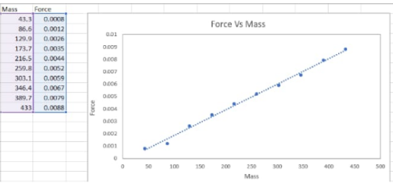
I_table 1_j. graph screenshot

The relationship between force and mass is a direct proportion defined by : F ∝ (k1)m

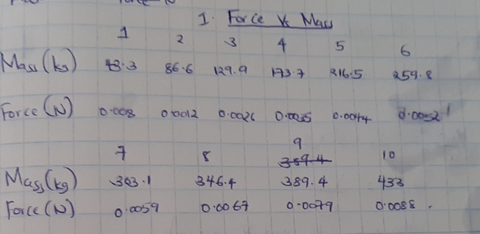

VPL Lab – Circular Motion, Centripetal Force 2 Rev 12/19/18

KET Virtual Physics Labs |  |  |  |  |  |  |  |  |  |  | KET © 2019

 | Table 2 |  | Force vs. Velocity |  |  |  | Chosen Cylinder letter: |  |  |  |  | B |  | Mass Mult. = 5
 | Mass of Cylinder |  |  |  |  |  | 0.255 kg |  | kg (with Min. Mass set to 5)
 | Radius of Motion |  |  |  |  |  | .1228 |  | m
 | Trial |  | Sug. Velocity | Actual Velocity |  |  |  |  |  | Force | Notes: (abbreviated)
 |  |  | (m/s) |  |  |  | (m/s) |  |  | (N) | a. |  | Choose a cylinder. Record letter as before.
 | 1 |  | 0.17 |  |  |  | 0.17 |  |  | 0.0597 |  | b. Set Mass Mult to 5. Measure and record the cylinder
 | 1 |  | 0.17 |  |  |  |  |  |  |  |  |  | mass.
 | 2 |  | 0.24 |  |  |  | 0.24 |  |  | 0.1186
 | 2 |  | 0.24 |  |  |  |  |  |  |  |  | c. | Drag and drop the Force Sensor near the center of the
 | 3 |  | 0.32 |  |  |  | 0.32 |  |  | 0.2102 |  |  | record. Place the cylinder on the record.
 |  |  |  |  |  |  |  |  |  |  |  | d. Set the radius to approximately the value specified above
 | 4 |  | 0.42 |  |  |  | 0.42 |  |  | 0.3624
 | 4 |  | 0.42 |  |  |  |  |  |  |  |  |  | the table. Adjust the cylinder to that radius.
 | 5 |  | 0.45 |  |  |  | 0.45 |  |  | 0.4165
 | 5 |  | 0.45 |  |  |  |  |  |  |  |  | e. | Turn on the turntable. Adjust the speed dial until VT
 | 6 |  | 0.5 |  |  |  | 0.5 |  |  | 0.5153 |  |  | equals approx. the first value listed in the suggested
 | 6 |  | 0.5 |  |  |  |  |  |  |  |  |  | velocity column. Record actual velocity.
 | 7 |  | 0.56 |  |  |  | 0.56 |  |  | 0.6444
 | 7 |  | 0.56 |  |  |  |  |  |  |  |  | f. | Record the Force Sensor reading.
 | 8 |  | 0.62 |  |  |  | 0.62 |  |  | 0.7901 |  | g. | With the mass still in place, repeat for a total of 13 trials.
 |  |  |  |  |  |  |  |  |  |  |  | h. Create a Force vs. velocity graph with your data. Create
 | 9 |  | 0.69 |  |  |  | 0.69 |  |  | 0.9794
 | 9 |  | 0.69 |  |  |  |  |  |  |  |  |  | and save Screenshot as before. Don’t forget labels.
 | 10 |  | 0.79 |  |  |  | 0.79 |  |  | 1.2845 |  | i. | Use Grapher and your linearization skills to produce a
 |  |  |  |  |  |  |  |  |  |  |  |  | linear graph. Create and save Screenshot.
 | 11 |  | 0.88 |  |  |  | 0.88 |  |  | 1.5944
 | 11 |  | 0.88 |  |  |  |  |  |  |  |  | j. | Paste both graphs below. Or email.
 | 12 |  | 0.96 |  |  |  | 0.96 |  |  | 1.8966 |  | j.
 | 13 |  | 0.98 |  |  |  | 0.98 |  |  | 1.9771

VPL Lab – Circular Motion, Centripetal Force 3 Rev 12/19/18

- Look back at the table of seven relations at the start of Section I. What is the relationship between the centripetal force and the velocity? State this as an equation using k2 for the constant of proportionality.

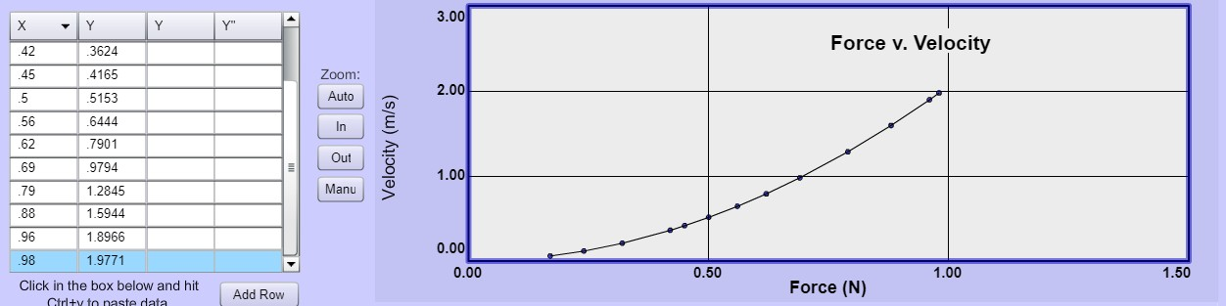
I_table 2_j. graph screenshot

The relationship between centripetal force and the velocity is an inverse square proportion F ∝ v2

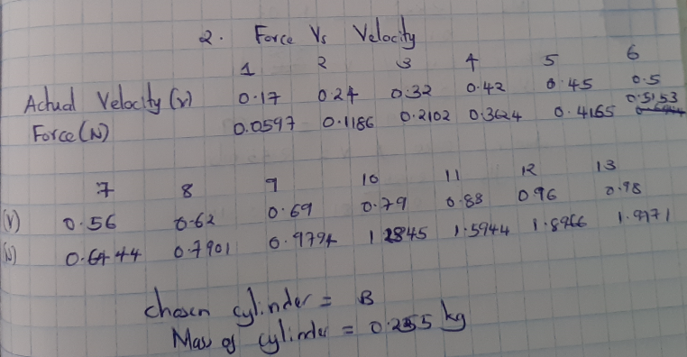

VPL Lab – Circular Motion, Centripetal Force 4 Rev 12/19/18

KET Virtual Physics Labs |  |  |  |  |  |  |  |  |  |  |  |  |  |  | KET © 2019
 |  |  | Table 3 Force vs. Radius |  |  |  |  | Chosen Cylinder letter: |  |  |  |  | B |  | Mass Mult. = 5
 |  |  | Mass of Cylinder |  |  |  | 0.255 |  |  | kg (with Min. Mass set to 5)
 |  |  | Velocity of Cylinder |  |  |  |  | .3 |  | m/s
 | Trial | Sug. Radius |  | Radius |  | Force |  |  |  |  | Notes: (abbreviated)
 |  |  | (m) | (m) |  |  |  |  |  |  | a. | Choose a cylinder. Record letter as before.
 | 1 | 0.060 |  | 0.0601 | .090 |  |  |  |  |  | b. | Set Mass Mult to 5. Record cylinder mass.
 |  |  |  |  |  |  |  |  |  |  | c. | Drag and drop the Force Sensor near the center of the
 | 2 | 0.068 |  |  |  |  |  |  |  |  | c.
 | 2 |  |  | 0.0681 | .101 |  |  |  |  |  |  | record. Place cylinder on the record.
 | 3 | 0.076 |  | 0.076 | .114 |  |  |  |  |  | d. | Set the radius to approx. first value listed in suggested
 |  |  |  |  |  |  |  |  |  |  |  | radius column. Record actual value. Adjust the
 | 4 | 0.084 |  | 0.0841 | .126
 | 4 |  |  |  |  |  |  |  |  |  |  | cylinder to that radius. Turn on the turntable.
 | 5 | 0.092
 | 5 |  |  | 0.092 | .137 |  |  |  |  |  | e. | Adjust the speed dial to set VT to approx. velocity
 | 6 | 0.100 |  | 0.0999 | .149 |  |  |  |  |  |  | specified above.
 |  |  |  |  |  |  |  |  |  |  | f. | Record the Force Sensor reading.
 | 7 | 0.108 |  |  |  |  |  |  |  |  | f.
 | 7 |  |  | 0.1082 | .163 |  |  |  |  |  | g. | Repeat d-f until all radii have been used.
 | 8 | 0.116 |  | 0.1161 | .174 |  |  |  |  |  | h. | Create a Force vs. radius graph with your data.
 |  |  |  |  |  |  |  |  |  |  |  | Screenshot and save as before.
 | 9 | 0.124 |  | 0.1241 | .186
 | 9 |  |  |  |  |  |  |  |  |  | i. | Use Grapher and your linearization skills to produce a
 | 10 | 0.132 |  |  | .196 |  |  |  |  |  |  | linear graph. Screenshot and save.Paste both graphs
 |  |  |  | 0.1278 |  |  |  |  |  |  |  | below. Or email.

VPL Lab – Circular Motion, Centripetal Force 5 Rev 12/19/18

- Look back at the table of seven relations at the start of Section I. What is the relationship between the centripetal force and the mass? State this as an equation using k3 for the constant of proportionality.

Hopefully you have verified that F ∝ m, and F ∝ v², and F ∝ 1/r. It can be shown that if one variable is proportional to several others, it is also proportional to their product. So F ∝ m v²/r. And F = k m v²/r

In this case, no constant is needed due to the way that we define the Newton in terms the kg, m and s. So we do get the centripetal force equation, FC = m v²/r, that we were seeking.

Let’s put this equation to some practical use by using it to help us understand the behavior of cars on slippery roads.

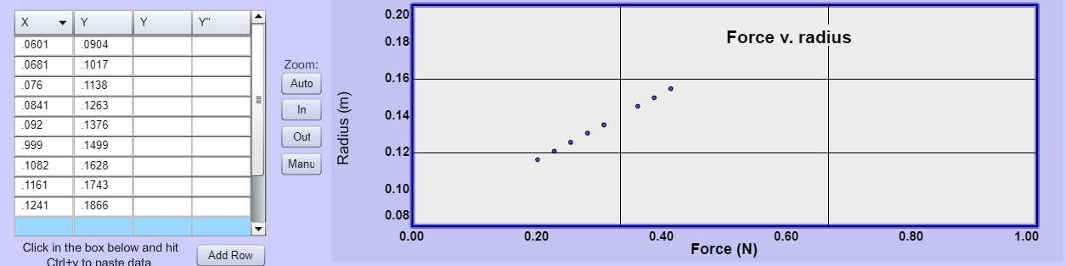

I_table 3_graph screenshot

The relationship between force and radius is a direct proportion defined by F ∝ (K3)/r

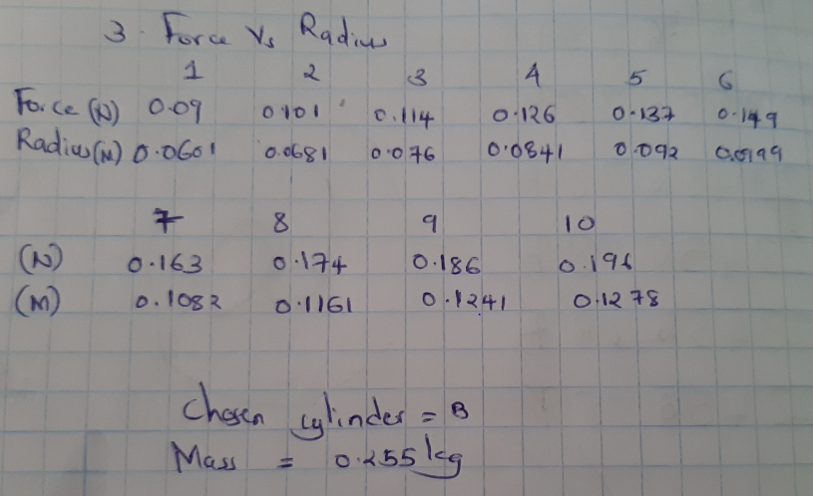

VPL Lab – Circular Motion, Centripetal Force 6 Rev 12/19/18

KET Virtual Physics Labs KET © 2019

Part II: Friction Acting as a Centripetal Force

Table 4 VT^{max} vs. mass
Fixed radius |  |  | .13 | m
Min | mass |  |  |  | _{VT}max |  |  |  |  | Fcentripetal
Mass # | (kg) |  |  |  | (m/s) |  |  | (m/s) |  | (N)
1 | 0.0045 |  | 2.58 |  | 2.55 | 2.60 |  | 2.57 |  | 0.228
2 | 0.0095 |  | 3.15 |  | 3.20 | 3.15 |  | 3.17 |  | 0.734
3 | 0.0145 |  | 4.17 |  | 4.15 | 4.15 |  | 4.16 |  | 1.930

- Based on your data, does VT^{max} depend on the mass of the object under our ideal circumstances? No it does not depends on mass of an object

- Does FC depend on the mass of the object? Yes Fc depends on the mass of the object.

So why aren’t both answers the same? Let’s get this straight.

  - Place your disk at the fixed radius you used above. Set the mass multiplier to 1. Gradually speed up to a bit below your lowest VT^{max}. The disk should stay on the record.

  - Increase the mass multiplier from 1 up to its maximum value of 10. The disk still doesn’t slide away!

The disk was just at the point of slipping and you added 9 times as much mass and you know that more mass requires more centripetal force. But still it doesn’t slip.

So how is this possible? It is possible because the static friction cancels out the mass and if we have a low velocity and a bigger radius this would reduce the centripetal force and th disk will not slide.
How is the centripetal force able to just increase as needed? When there is a higher velocity and a reducing radius and the centripetal force being at equilibrium with the static friction between the tires.

18 It keeps increasing because it’s a centripetal force and a static frictional force.

If you’re having difficulty with that question go back to the discussion in the first several paragraphs in Part II.
After some review you should be able to answer the following question too.

- Starting with FS = FC, explain why the mass does not matter in this situation.

Fs = $μF$ where $μ is coefficient of static friction and F is force which equals=mass ×acceleration$ .Fc equals to mv²/r which means on equating the two sides, the masses will cancel each other meaning the mass does not matter when static friction and centripetal force of same object with equal mass are equated.

So let’s have a second look at our initial question for this section.

- A car is rounding a curve at too high a speed and about to lose traction and slide off the road. If the car had more passengers inside would this happen at the same speed, a lesser speed or a larger speed? Assume that the passengers are evenly distributed so that that’s not a factor. (Circle one.)

same speed lesser speed greater speed
It would happen at the same speed

Driving Question 2. When you feel that your car may begin to skid on an icy curve, what should you do to maintain control of your car?

We just found that ejecting a passenger won’t work since mass is not an issue. And it’s rude. What other factors are there? At any given radius and speed there’s a specific centripetal force required to keep you in your circular path: Fc = mv²/r

If you change your path or speed so that you don’t have enough static friction what will happen?

So if the radius of your path gets small enough, or your speed gets large enough, the centripetal force required will become greater than the maximum static friction force available.
Static friction is like a responsive force that that enables the vehicle negotiate a curve, if there is less static friction, the car tires will skid.

21. If your new motion requires that Fc > fS^{max}, you will begin to |  |  |  | accelerate | . When this happens, the friction force
changes from | Static | friction to | kinetic | friction. Since μk |  | Equals | μs, you will have much less

friction available than before. So you’ll probably slide along out of control until some new force acts. Gulp.

22. Measure and record the mass, mdisk, for Disk B in Table 5.

- We’ll start with Path 0 – the middle path that follows the curve of the road. Adjust the radius to about 10 cm. Record the actual value in Table 5 in the Path 0 row.

- Center Disk B on the green circular line.

- Experimentally determine VT^{max} for this case by speeding up until the disk slips. Record your VT^{max} in Table 5. This represents the path where you stay in your lane rather than taking a smaller or larger radius path. Note also that VT^{max} is the maximum speed you can have along that path. That’s important in what follows.

- Consider a path like Path #1. That is, one a bit smaller in radius than Path 0. Maybe 8 or 9 cm in radius.

- Will VT^{max} be larger or smaller this time with the smaller radius? It will be smaller

- Experimentally determine VT^{max} for this case. Record VT^{max}. Think about how this compares to Path 0.

- Consider a path like Path #2. That is, one a bit larger in radius than Path 0. Maybe 11 or 12 cm in radius.

- Will VT^{max} be larger or smaller this time with the larger radius? It will be larger

- Experimentally determine VT^{max} for this case. Record VT^{max}. Think about how this compares to Path 0.

Table 5 VT^{max} 3 curvatures
Disk B mass |  | 0.225 |  |  |  | kg
 | Radius |  |  | _{VT}max |  |  | Static Friction Coefficient μS
Path | (m) |  |  | (m/s)
0 | 0.10 |  |  | 2.22 |  |  | 5.02
1 | 0.15 |  |  | 2.33 |  |  | 3.69
2 | 0.20 |  |  | 2.55 |  |  | 3.314

- Using your data from one of the three trials, determine the static friction coefficient of the vinyl/disk B material combination. Enter your value in the appropriate space in the table above. (Path 0, 1, or 2.)

- Show your calculations of this μS value in the space below. You should be able to figure that given that you’ve learned that static friction provides the centripetal force on non-banked roads… and vinyl records. You will have to think about this one, but here’s a good starting point.

= | FC = mv²/r | fS^{max} = μS FN = μS mdisk g

VPL Lab – Circular Motion, Centripetal Force 8 Rev 12/19/18

KET Virtual Physics Labs KET © 2019

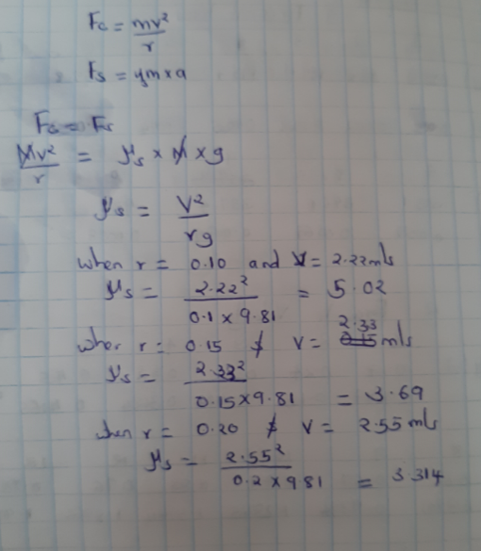

VPL Lab – Circular Motion, Centripetal Force 9 Rev 12/19/18

